# Lab 4: CSS Grid

1. Open the provided starting code. The given HTML displays commercial information about books. For each book, a picture, title, author and a buy button are included.
2. Put every group in an article.
3. Apply the flex layout approach to each article to display the elements vertically. Add every style necessary to obtain a result that is similar to the following example:

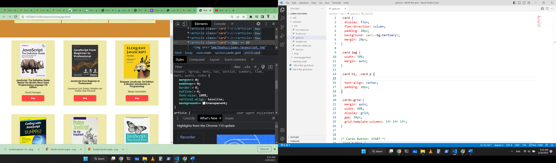

Fig. Example of one book flex box.

1. Include all the articles in a section element. Then, apply the grid approach to organize the flex boxes in a grid that displays at most three books per row. Here is an example of the expected result:

|  |  |
| --- | --- |
|  | 1. Use flex boxes to adjust the header, nav and the footer of the page. |